Spring Security

-Secure Spring MVC web apps

-Develope Login pages(def n custom)

-Define users and roles with simple Authentication

-Protect URL based on Role

-Use Jsp tags to hide /show content based on role

-Strore users,pwd and roles in DB (plain text -> encrypted)

Results

-common sprinf secuity task on project basics

Spring Security Model

-Defines framework for security

- Implemented using servlet filters in the background

-2 methods of securing a web app : declarative and programmatic

Spring Security with servlet Filters

-Servlet Filter used to pre/post process web request

-servlet filters can route web request based on security logic

-spring provides a bulk of security functionlity with servlet filters

Spring Security Overview

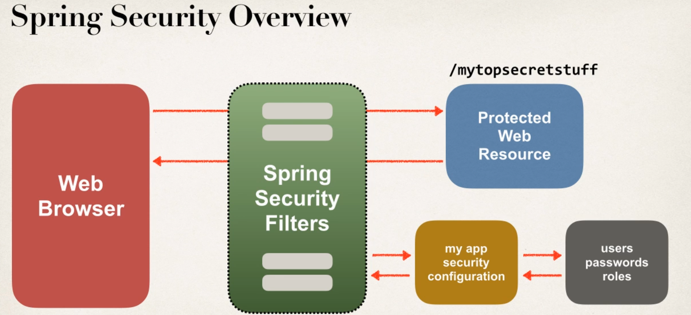

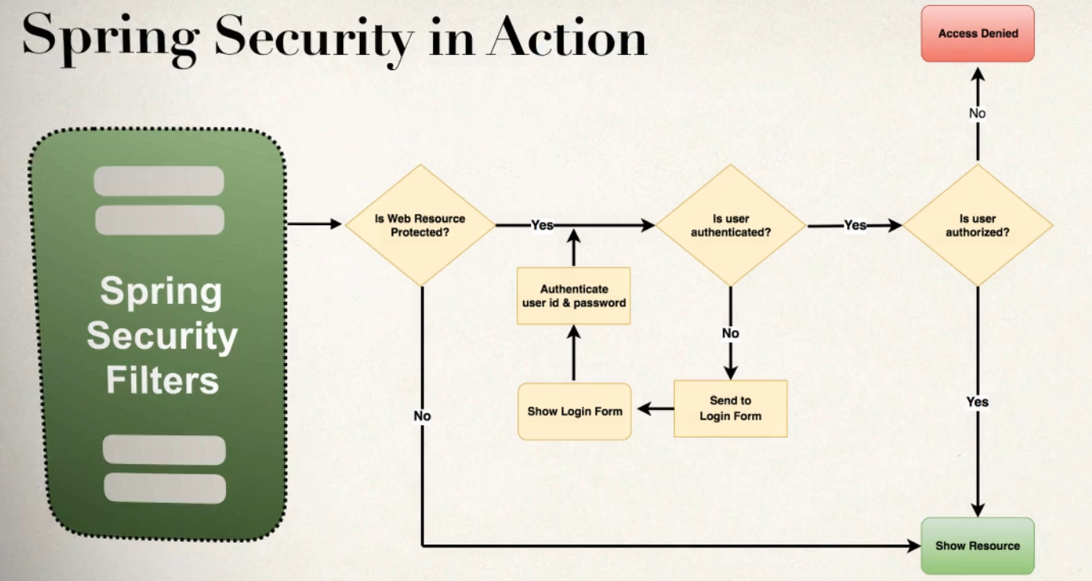

Security Concepts

A Authentication

-- check userid and pwd with credentials stored in app/db

B Authorization

--chcek if user has an authorized role

Declarative Security

-Define application’s security constriants in configuration

-- All java config (@configuration ,no xml)

-- or Spring XML config

-provides separation of concerns between applcation code and security

Programmatic Security

-Spring Security provides an API for custom Application coding

-Provides greater customization for specfic app requirements

Different Login Method

-HTTP Basic Authentication

-default Login form -> spring security provides default login form

-custom Login form

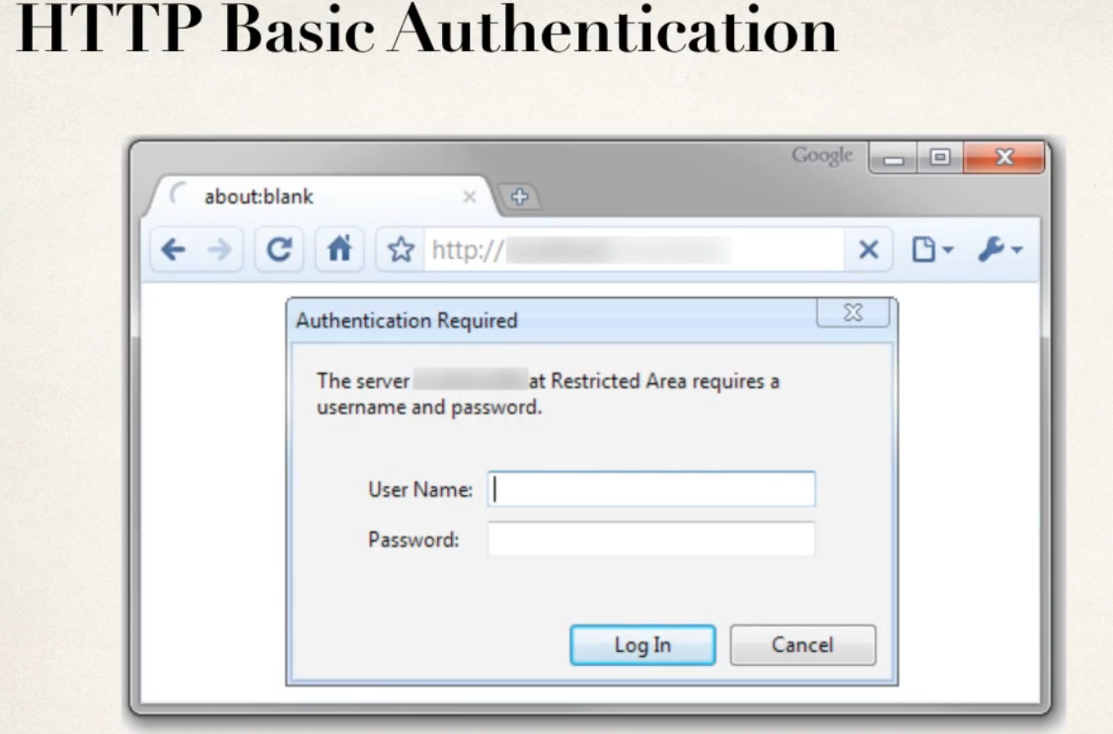

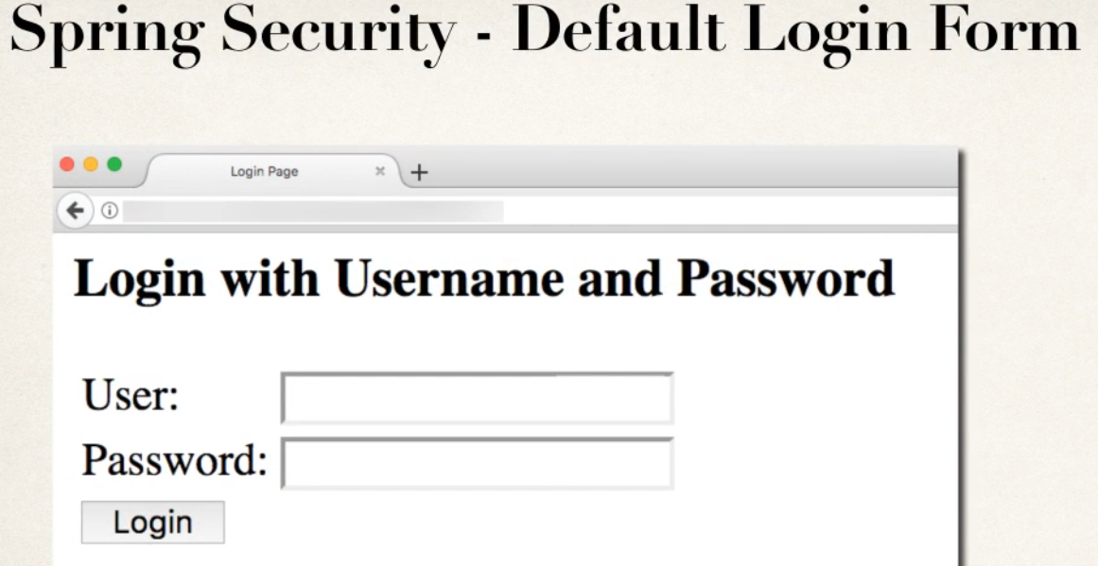

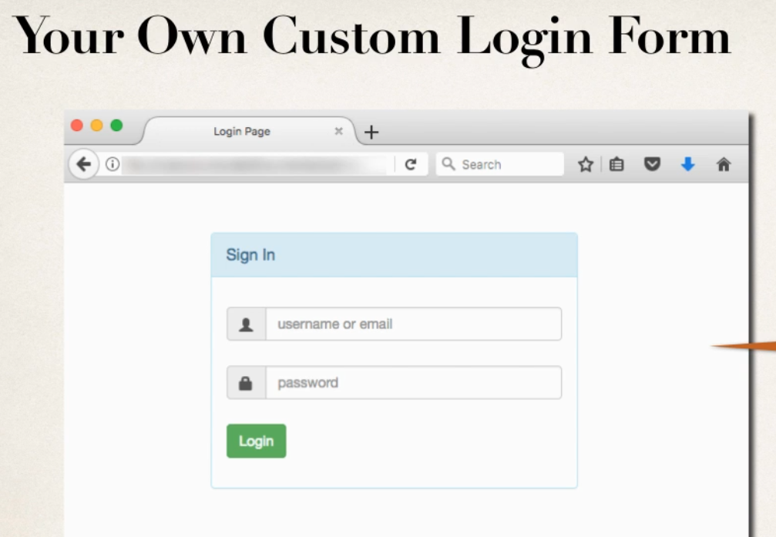

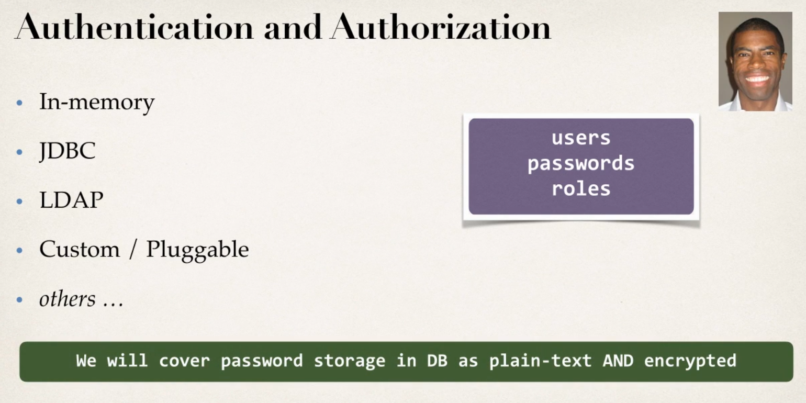

Demo Example

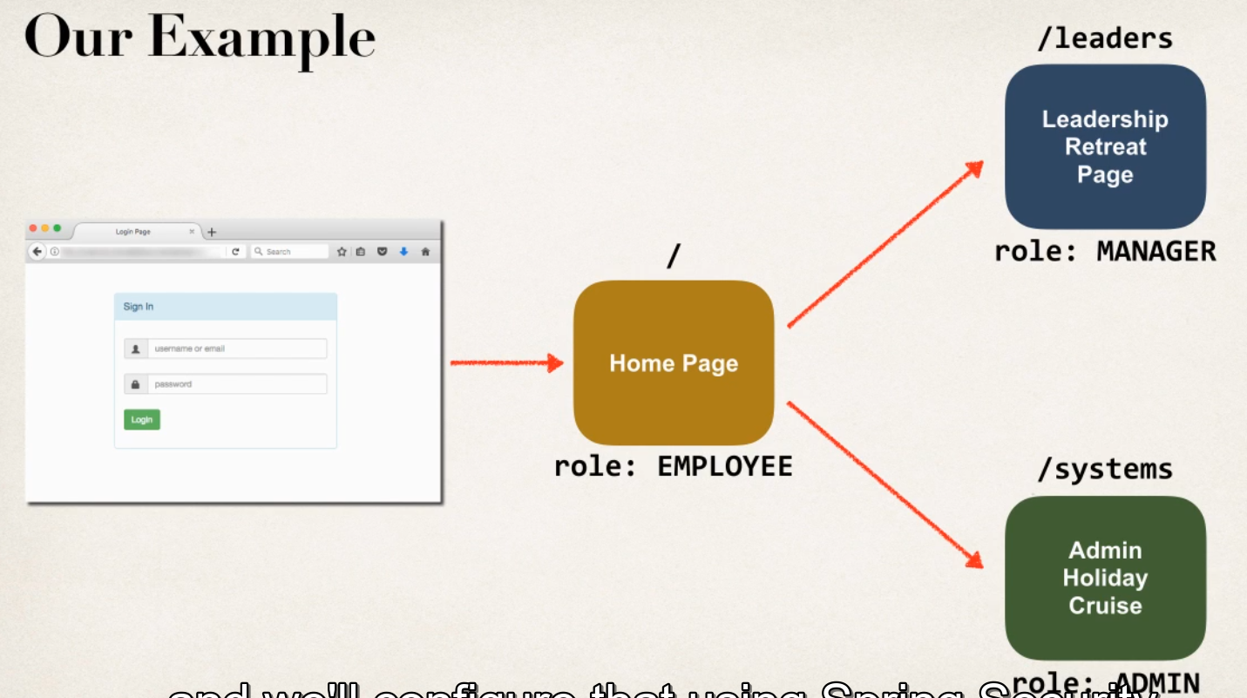

Spring Java Configuration

1 instead of configuring Spring MVC app using XML

-web.xml

-dispatcher-servlet.xml

2 configure spring MVC app with java code

Development Process

1 add Maven dependencies for Spring MVC webapp

2 Create Spring App Configuration (@Configuration)

3 create Spring Dispatcher Servlet Initializer

4 Develop spring contoller

5 Develop JSP view page

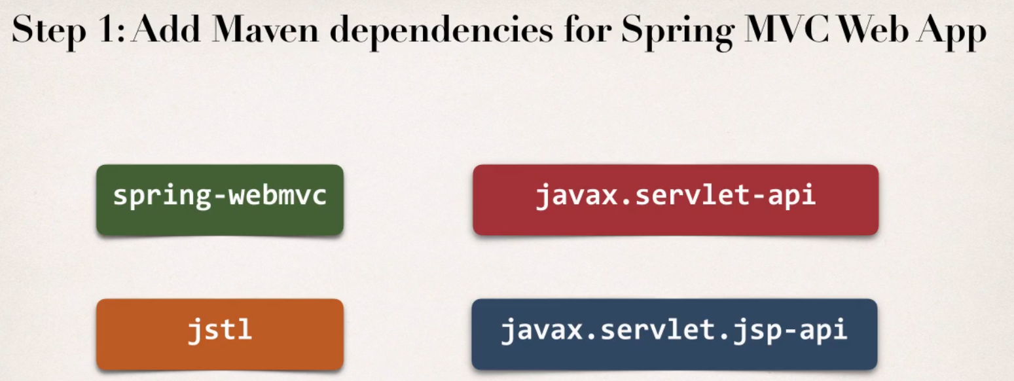

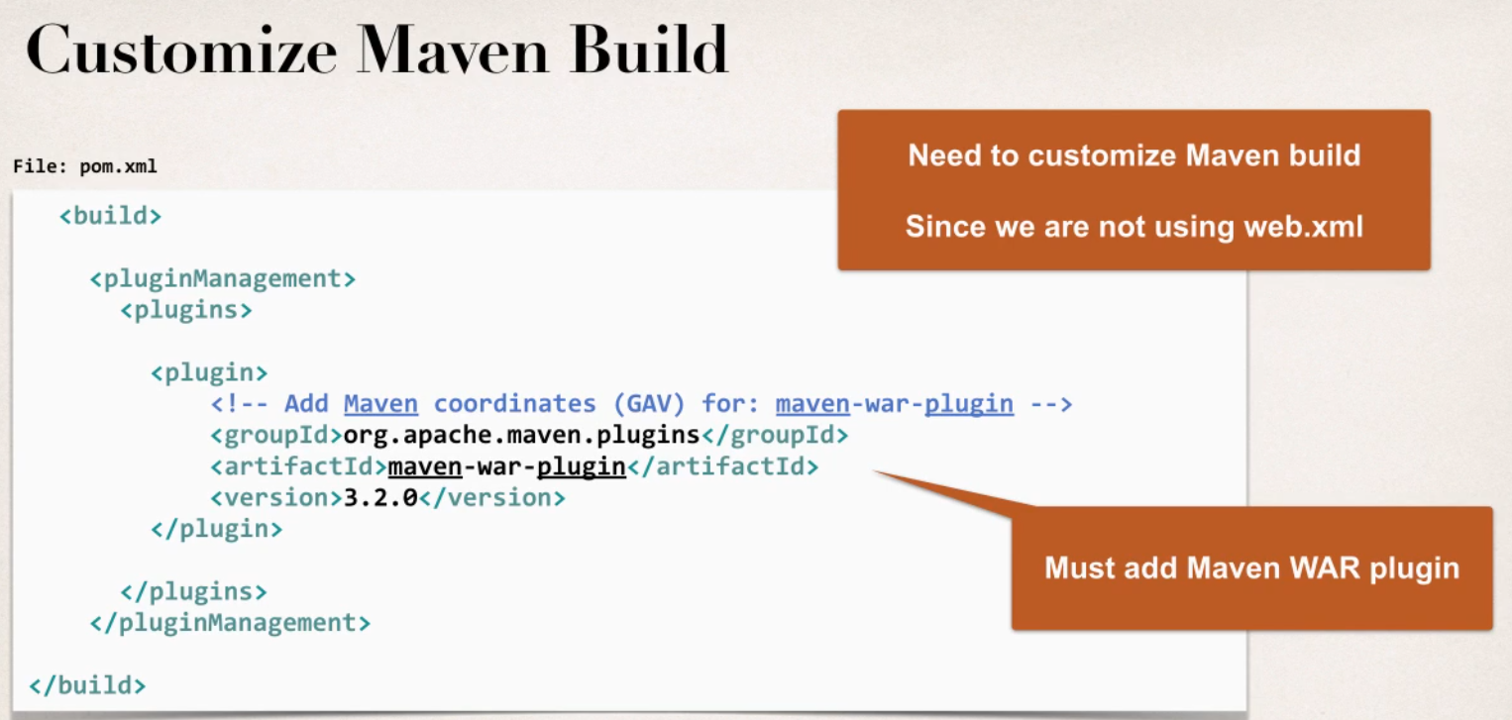

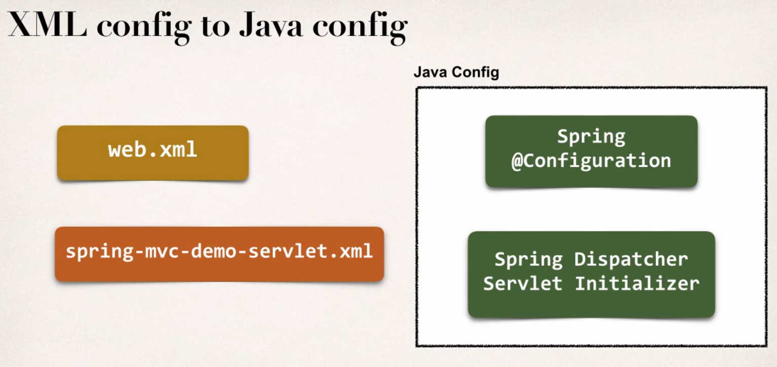

Enabling the MVC java Configurtaion

@EnableWebMvc

1Provide simlar support to <mvc:annotation-driven/> in XML

2 Adds conversion,formatting and validation support

3 also processing @Controller classes and @RequestMapping etc methods

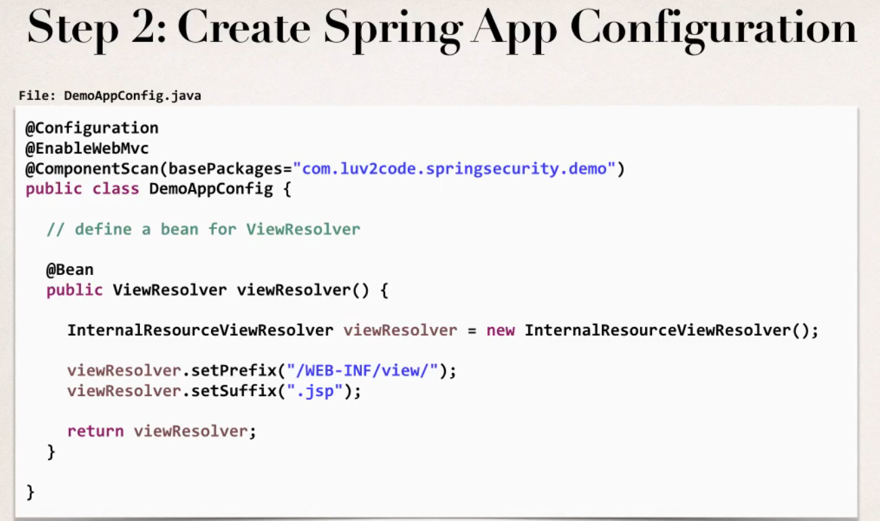

Web App Intializer

-Spring MVC provides support for web app intialization

-make sure code automaticlaly detected, code is used to intialize servlet container

Class



-Extend this abstract base calss

-overide required methods

-Specify servlet mapping location of your app config

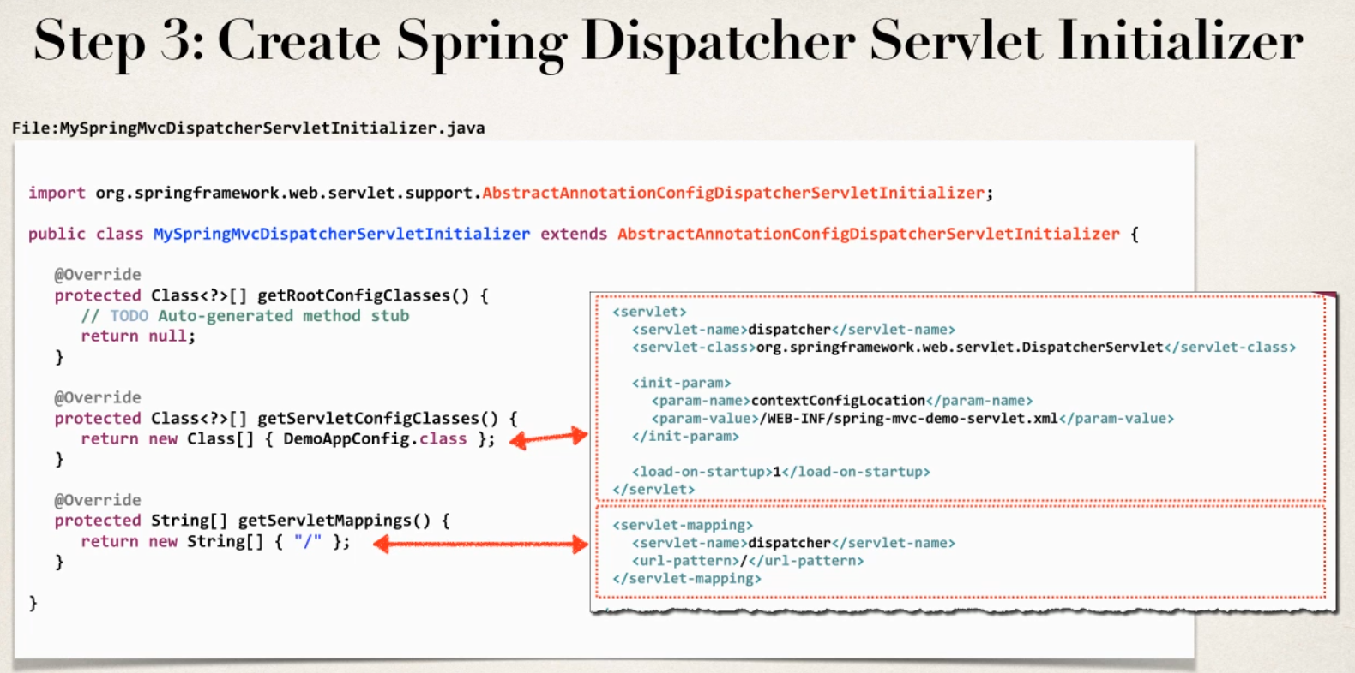

Step 1

/**

*

* **@author** User

* **@Configuration** since it is configuration class

* **@EnableWebMvc** provide support <mvc:annotaion-driven/>

* **@ComponentScan** which is to scann packages for IO

*/

@Configuration

@EnableWebMvc

@ComponentScan(basePackages="com.secuirty.demo")

public class DemoAppConfigClass {

// define a bean View Resolver

@Bean

public ViewResolver viewResolver() {

InternalResourceViewResolver viewResolver=new InternalResourceViewResolver();

viewResolver.setPrefix("/WEB-INF/pages/");

viewResolver.setSuffix(".jsp");

return viewResolver;

}

}

Step 2

public class MySpringMvcDispatcherServletIntializer extends AbstractAnnotationConfigDispatcherServletInitializer {

@Override

protected Class<?>[] getRootConfigClasses() {

// **TODO** Auto-generated method stub

return null;

}

@Override

protected Class<?>[] getServletConfigClasses() {

// **TODO** Auto-generated method stub

return new Class[] {DemoAppConfigClass.class}; // configure dispatcher serlvet

}

@Override

protected String[] getServletMappings() {

// **TODO** Auto-generated method stub

return new String[] {"/"}; //request url mapping

}

}

Step 3

@Controller

public class DemoController {

private Logger myLogger=Logger.getLogger(getClass().getName());

@GetMapping("/")

public String showHome() {

myLogger.info("===>Load Page ");

return "home";

}

Add Maven dependency for spring security

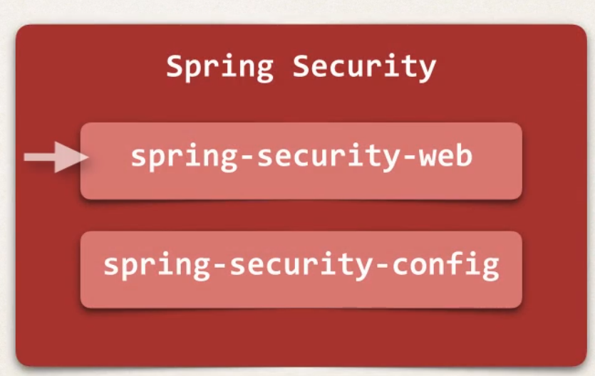

Spring Projects

- These are two separate projects

- projects are different release cycle

- version numbers between dnt sync

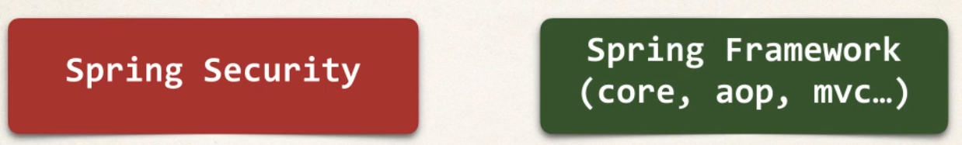

-- common pitfall is incompatiable project so find compatiable version

Finding Compiatble Version

-find desrired version of spring security in Maven central Repo

Spring-security-web

-look at project pom.xml and find supporting SpringFramework version

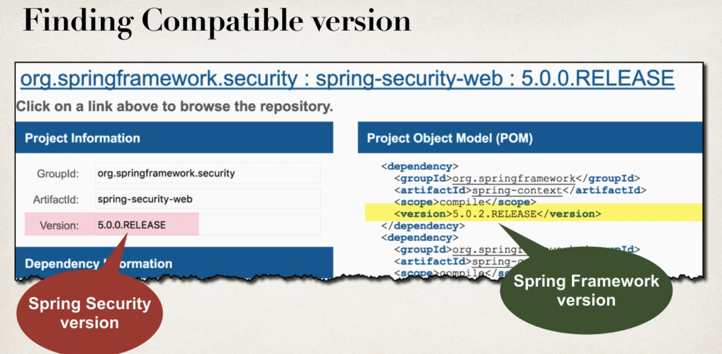

Development Process

1 create Spring Security Initilizar

2 create Spring secuirty configuration(@Configuration)

3 Add userid,pwd and roles

Step 1

Spring Security Web App Initalizer

-Spring security provides support for secuirty intialization

-you security code is used to intialize the servlet container

-specail class to register the spring security filters



-important to extend this class without it security is not possible

-Extend this Abstract base class

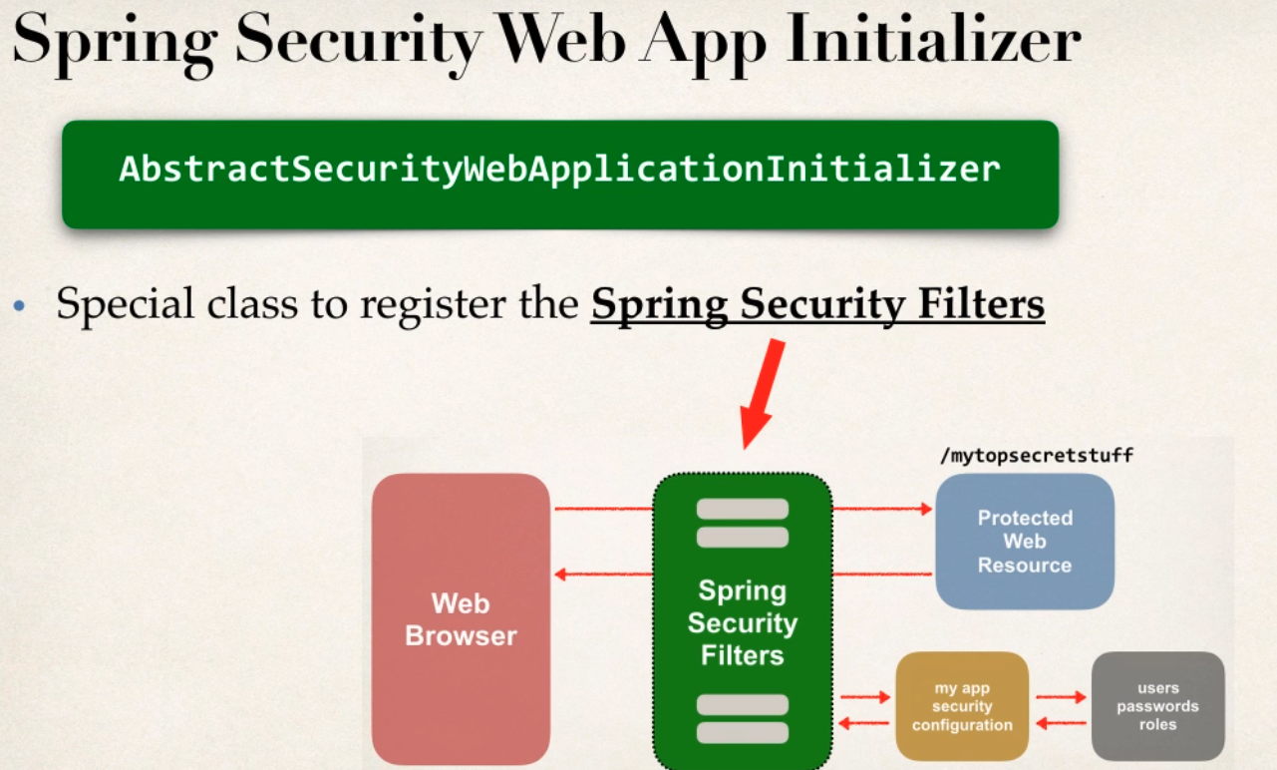

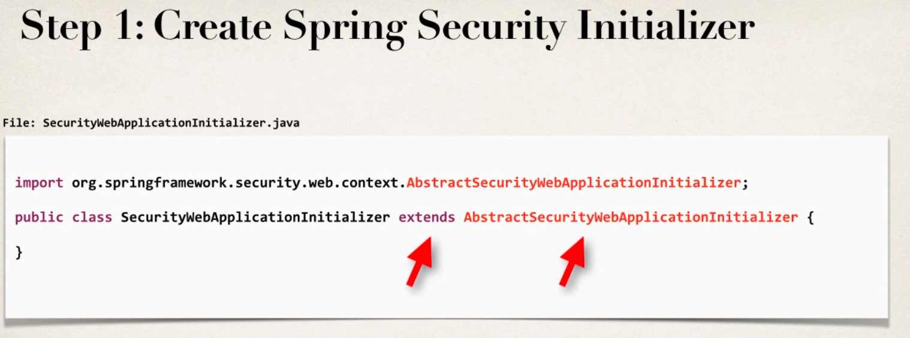

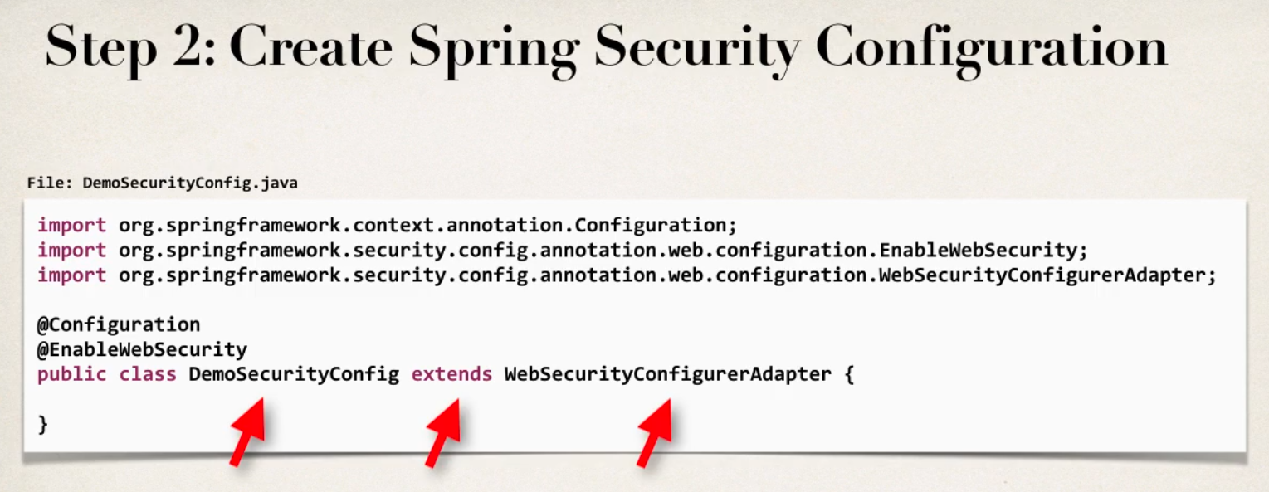

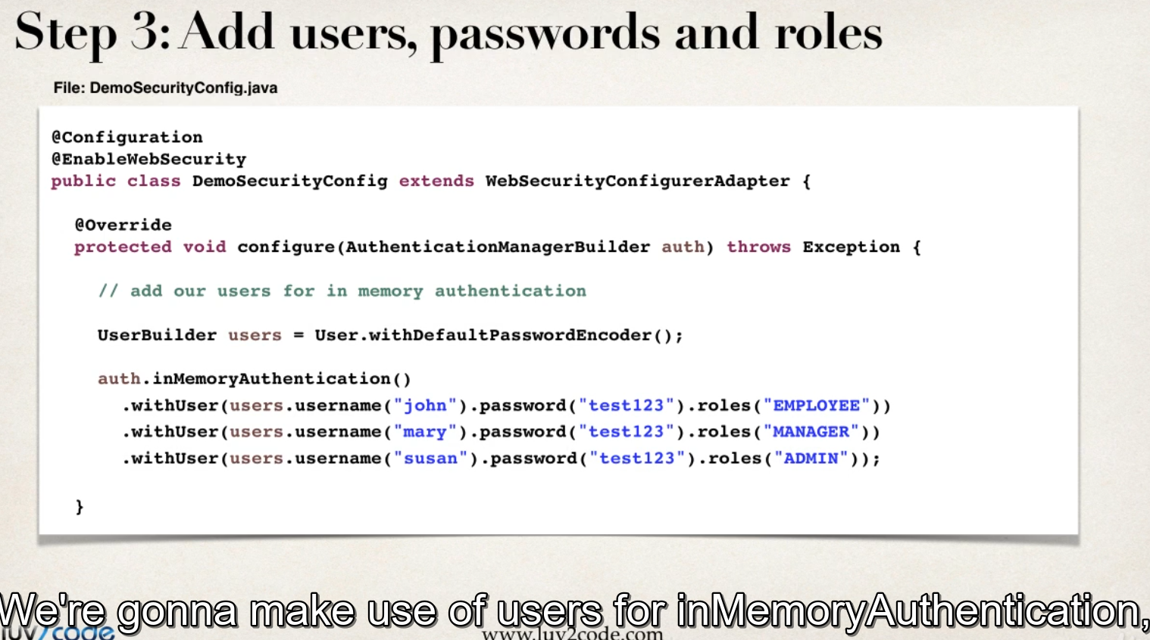

-

Use in memory Athuntication

Spring Secuity will provide default login page can check afterlogin page

Context Root?

-- root path of our web app

- to change it project -property-web project setting - change name to same r custom

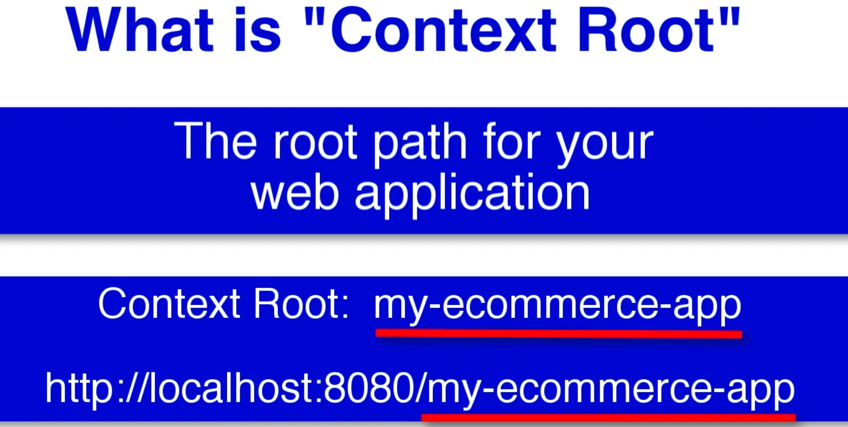

Dev and Testing with new PRivate Window

Dev and Testing an issues noticed user stays logged in if any change in the code like jsp or class file come back to browser refesh still it show logged page not login page which is not ideal

- why ? bcz user logger in based on “web browser session ” as long as browser running r process running it is automatically logged in

-This is only issue in during dev and testing phase

-not an issue when deployed to production/real time

Solutions to above issue

1 start a new Browser

2 quit browser and start again

3 new private window(always provides new seesion incongnito mode so always ask login page)

Spring Security Custom Login form

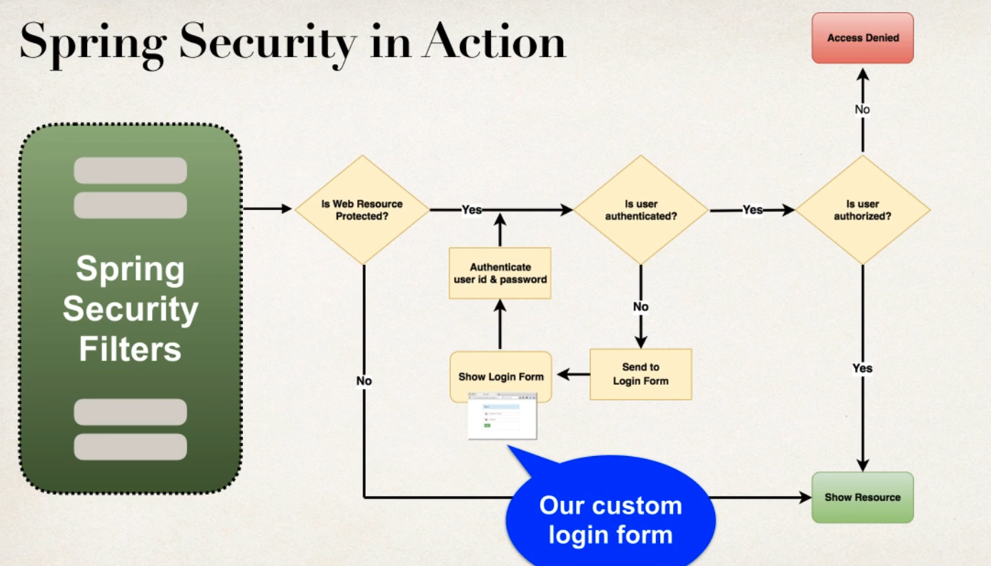

Development Process

1 Modify Spring security Configuration to reference custom login form

2 Develop a controller to show custom login form

3 create custom Login form with css and SpringMVC form

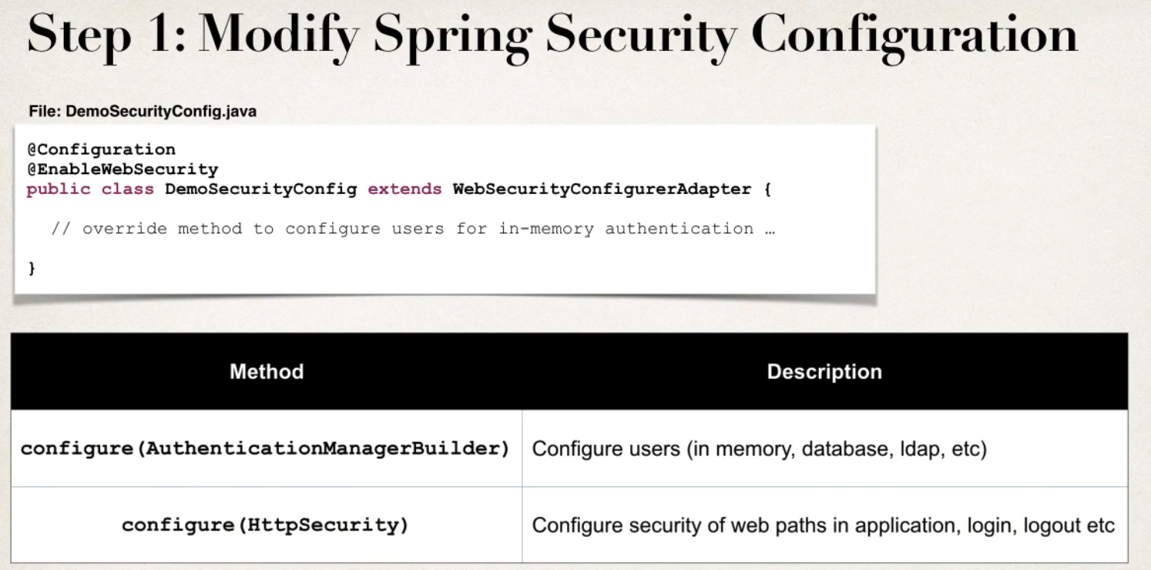

-second mehtod configure is overrided that takes parameter for HttpSecurity- used to security of web paths in apps . login and logout process so on

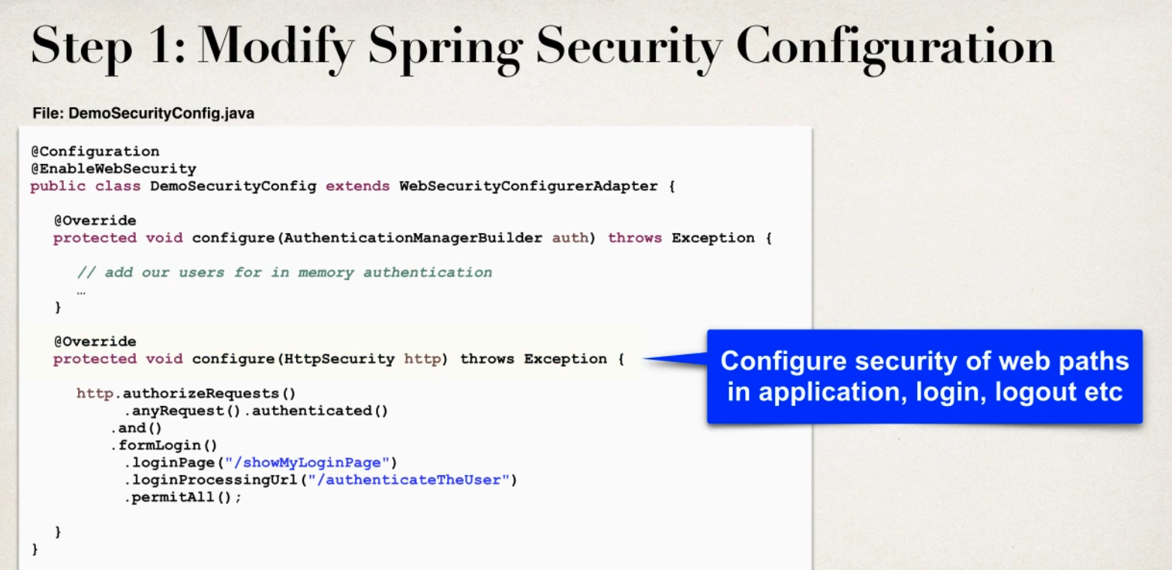

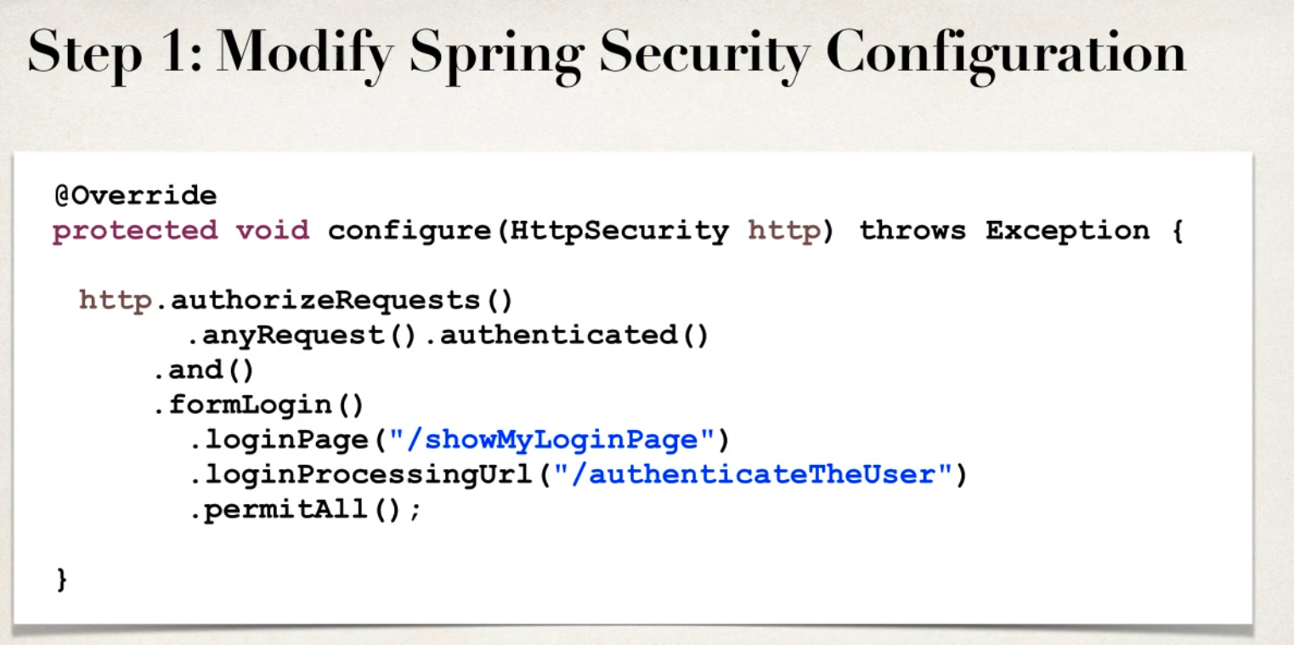





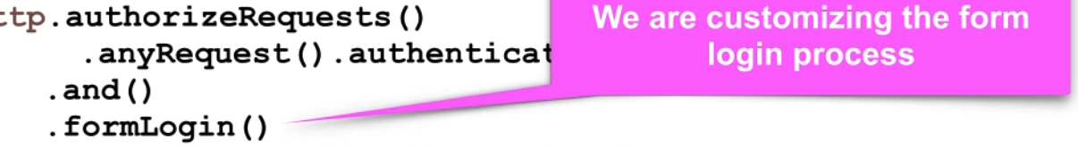

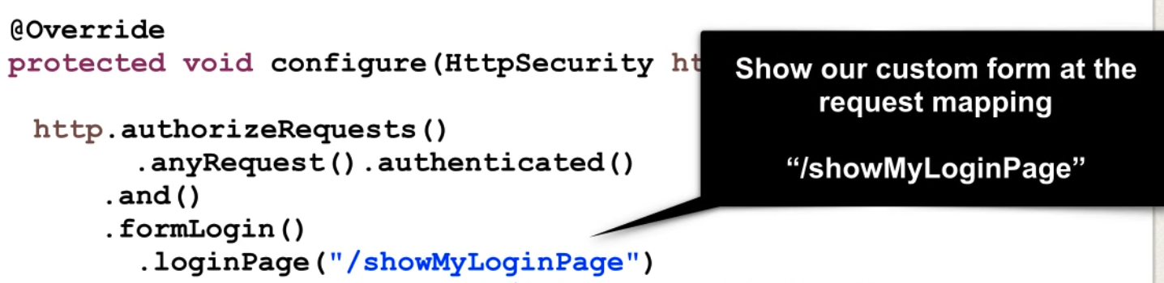

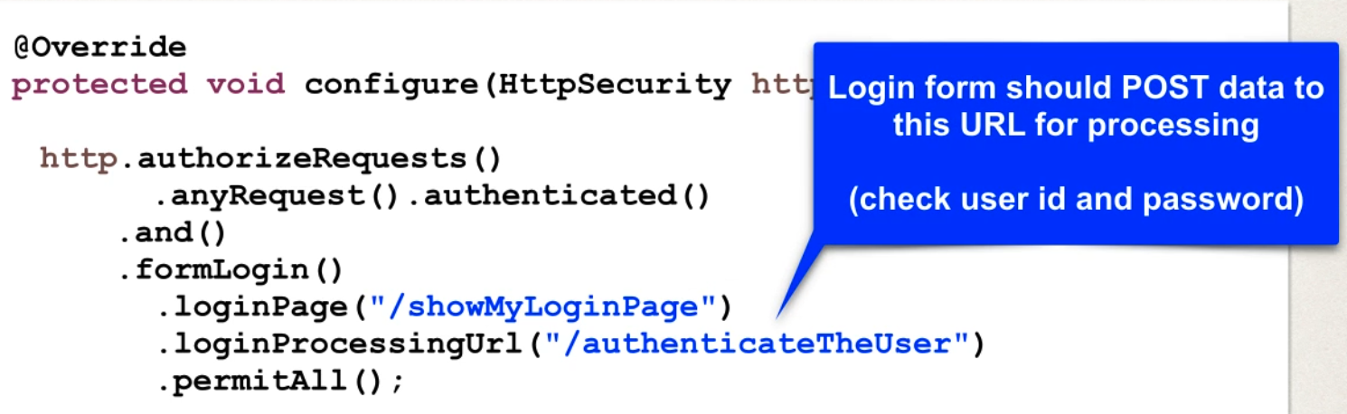

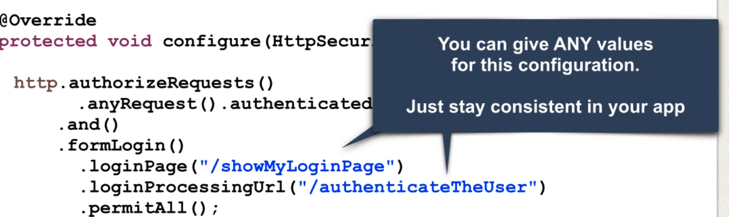

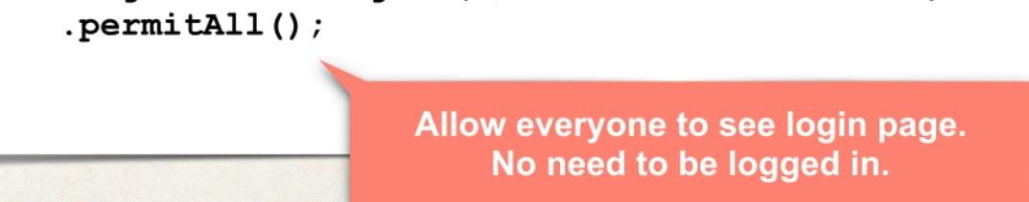

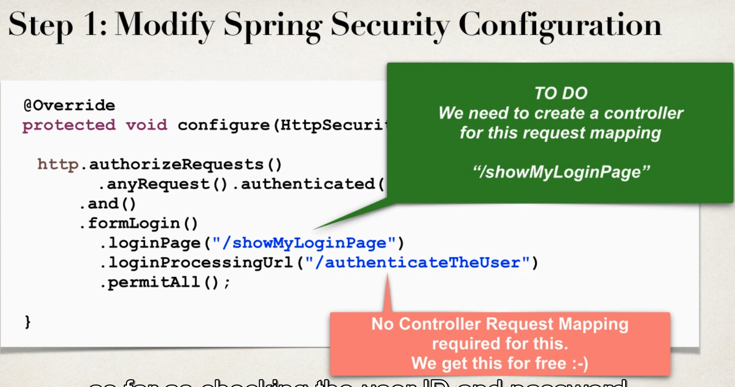

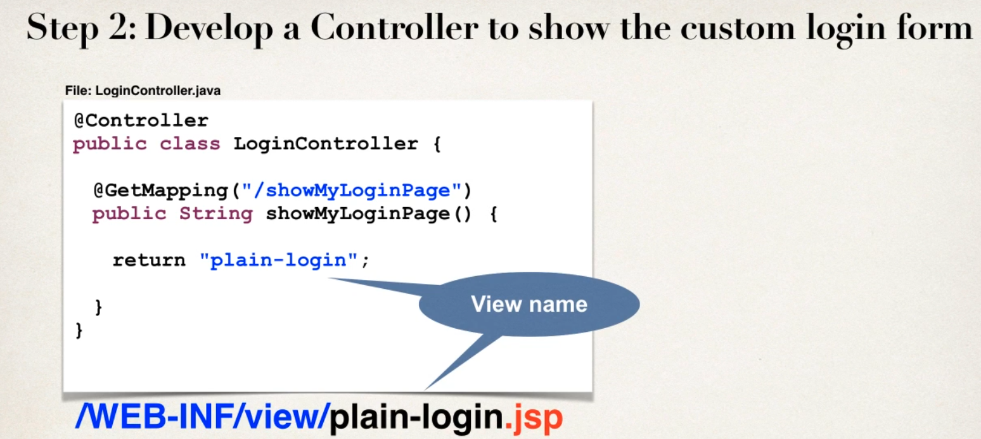

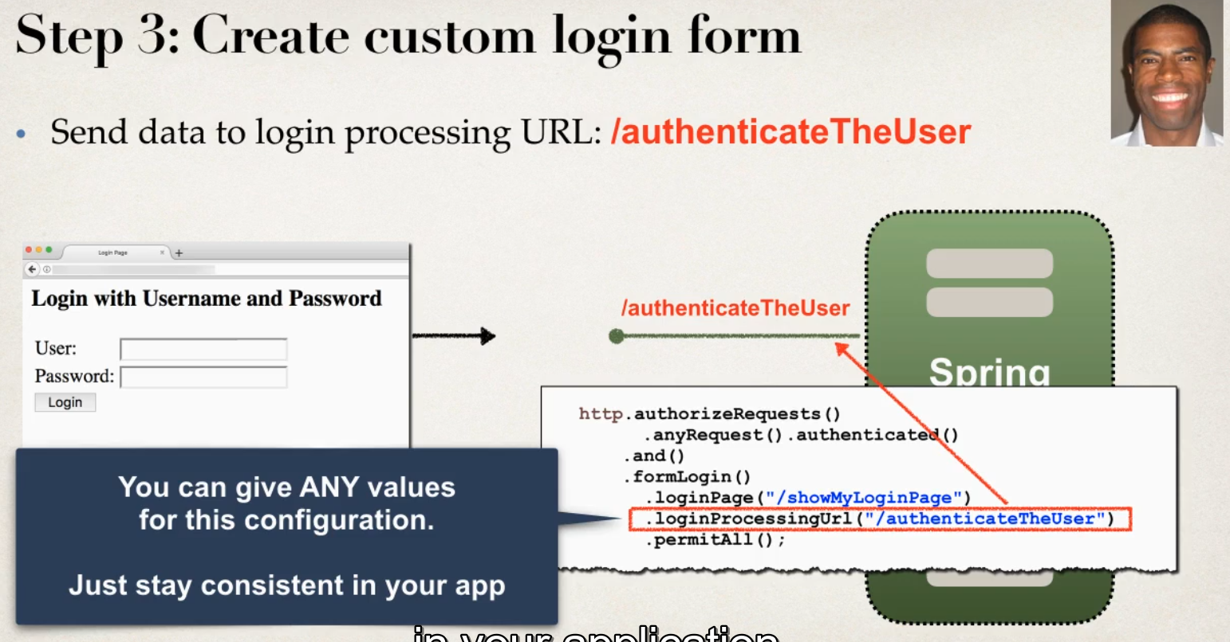

Step 3 :

-sending data to login processing URL :/sameurl as in configur method we can chosse any url but should in proper read format

-Login process URL will be handled by Spring secuity filters

-no coding

Best Practice use Spring MVC form bcz automatic support for security defence

-contextroot / contextpath both basically same

-context path alllows us to reference context path of application,helpr to keep it relative to application context path

- chnage in context path of app links will still work , btr then coding

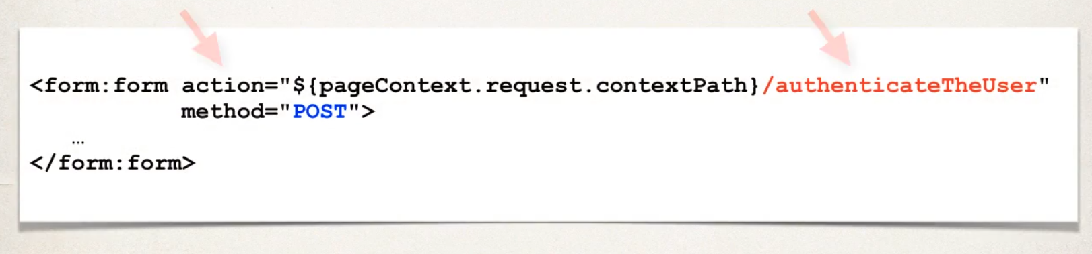

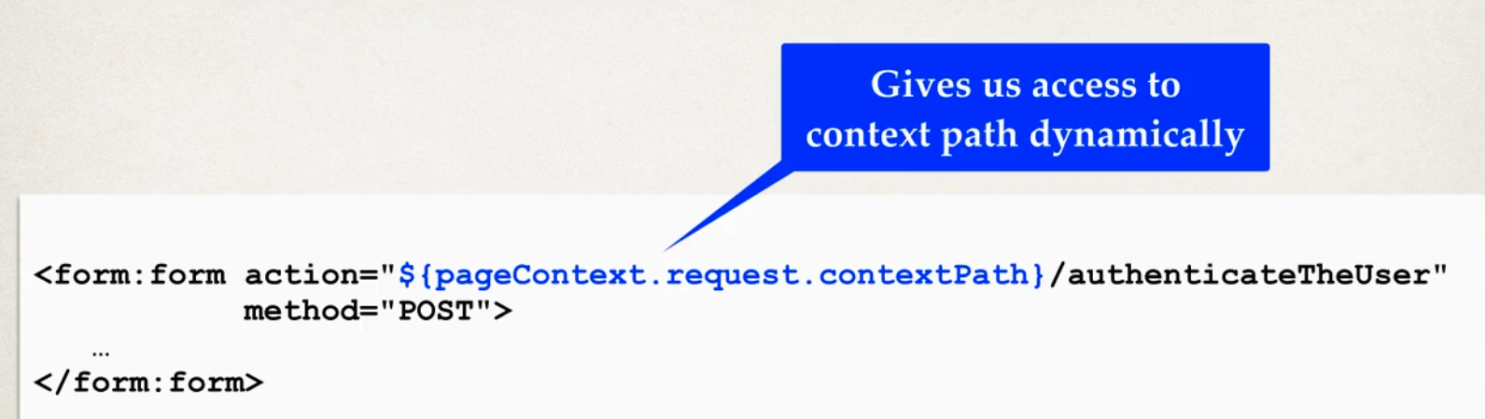

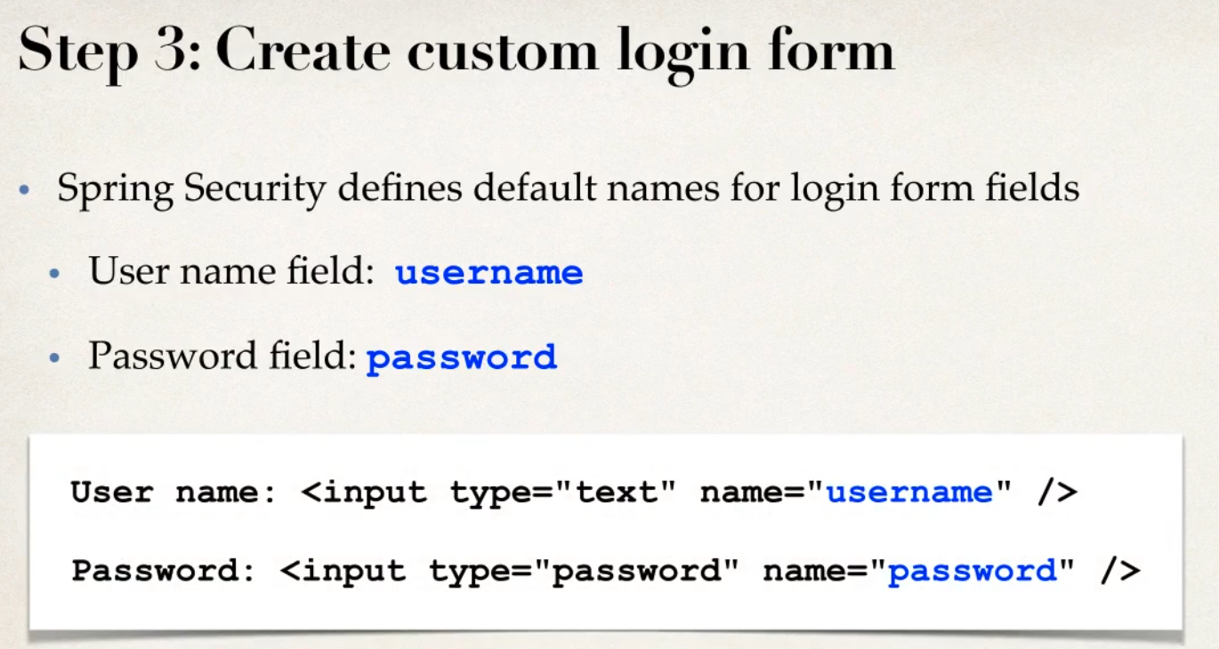

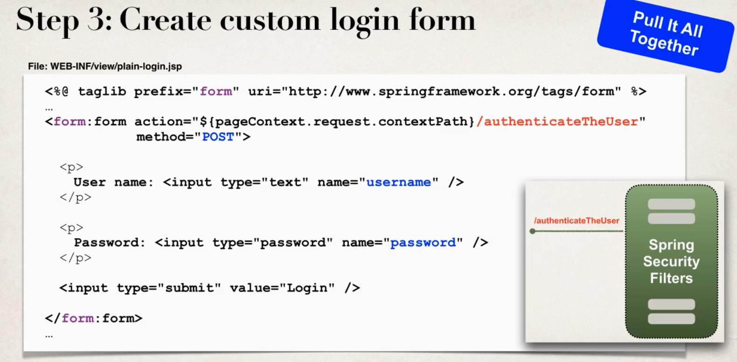

No errormsg in custom since it is from us not default spring page

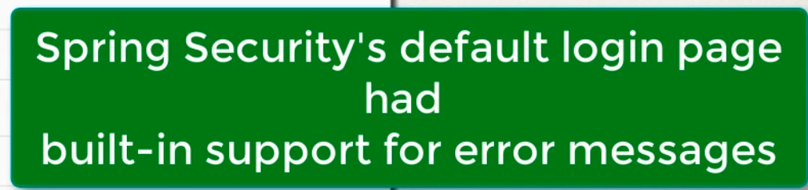

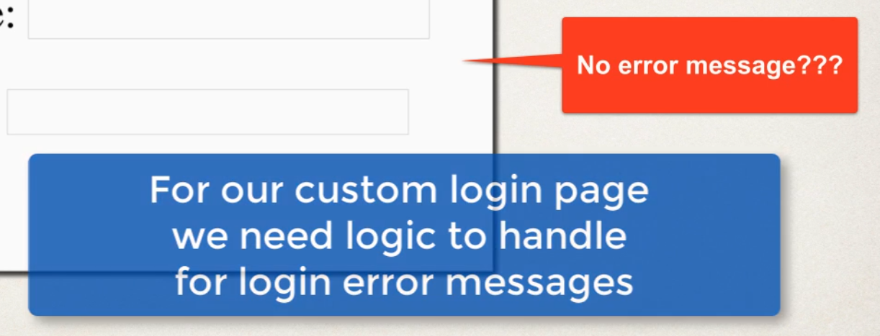

Failed Login

- when login fails , by default spring secuity will send back to login page with an append parameter ?error

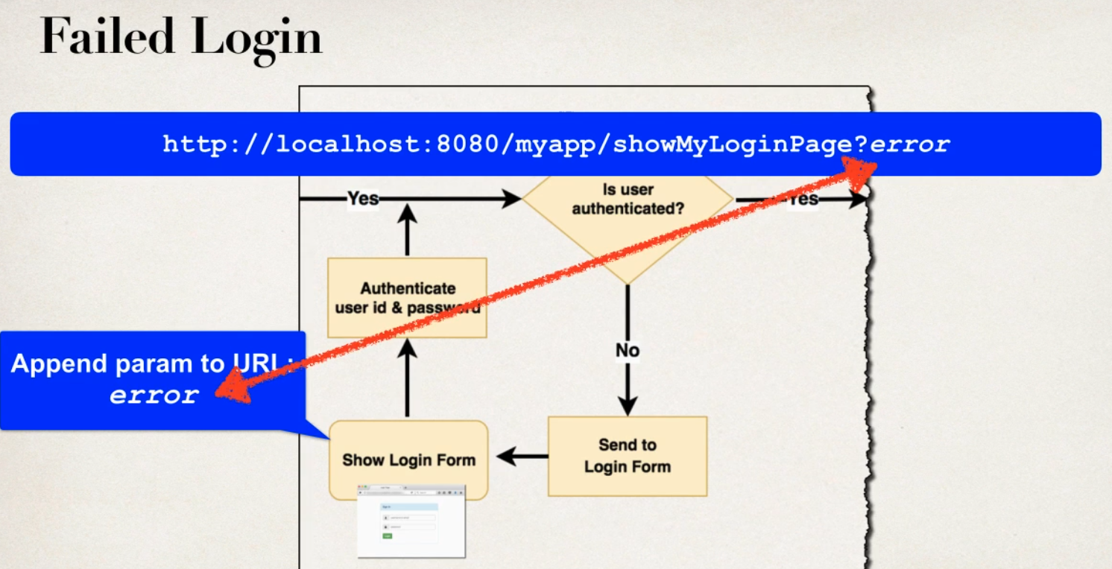

Development Process

1 Modify Customer Login page

2 check error parameter if parameter exist show an error msg

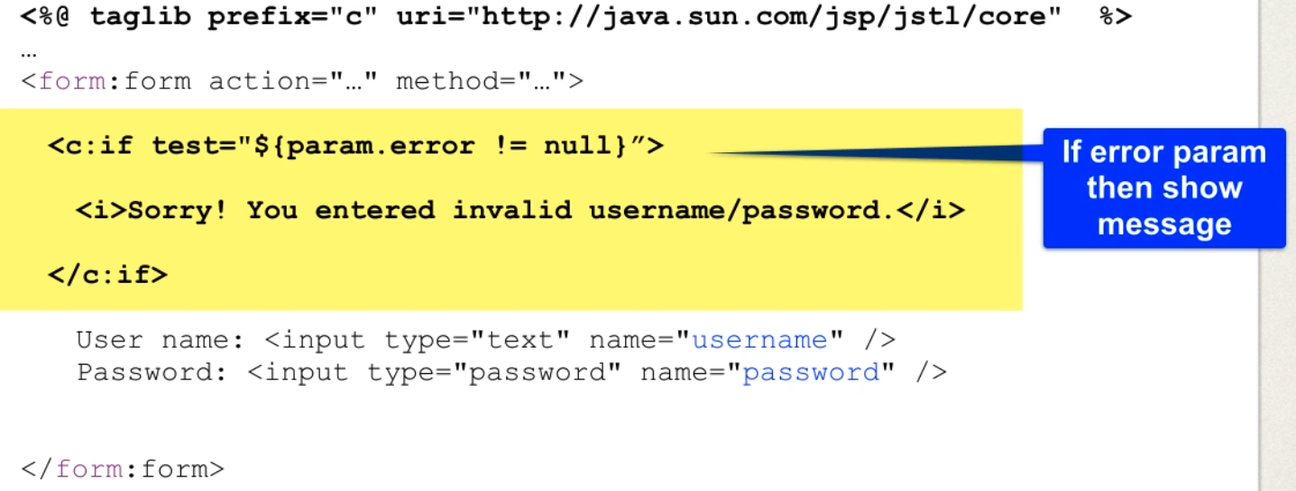

To change ContextRoot of project: project > Setting > web Project Setting change Context Root

Context Root is the root path of web application

Bootstrap CSS to login Form

Form Will be Designed

Logging out

- clears users session

Development

1 Add logout support to spring security configuration

2 add logout option to jsp

3 update login form to display logged out message

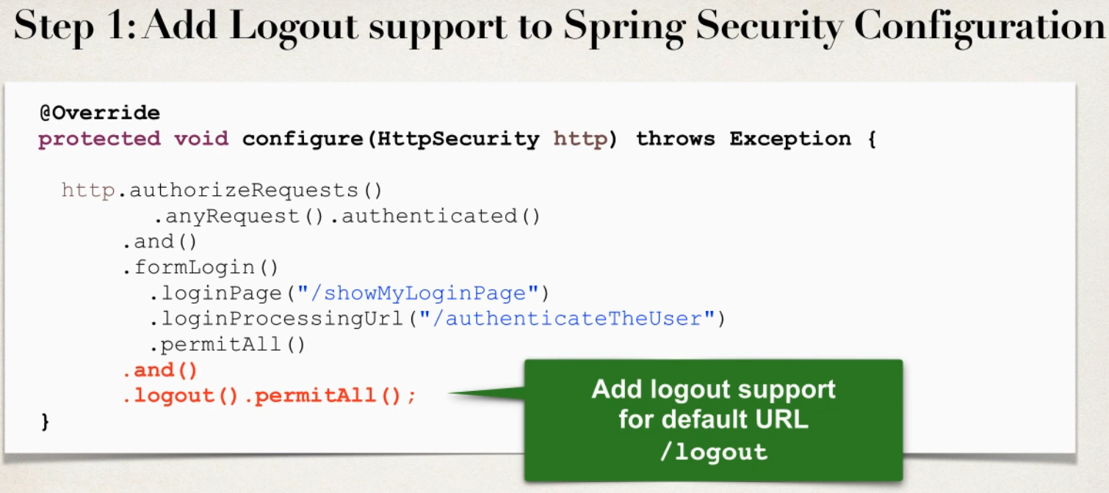

Step 2

1 send data to default logout url: /logout

2 logout url will handled by Spring secuirty filters no coding required

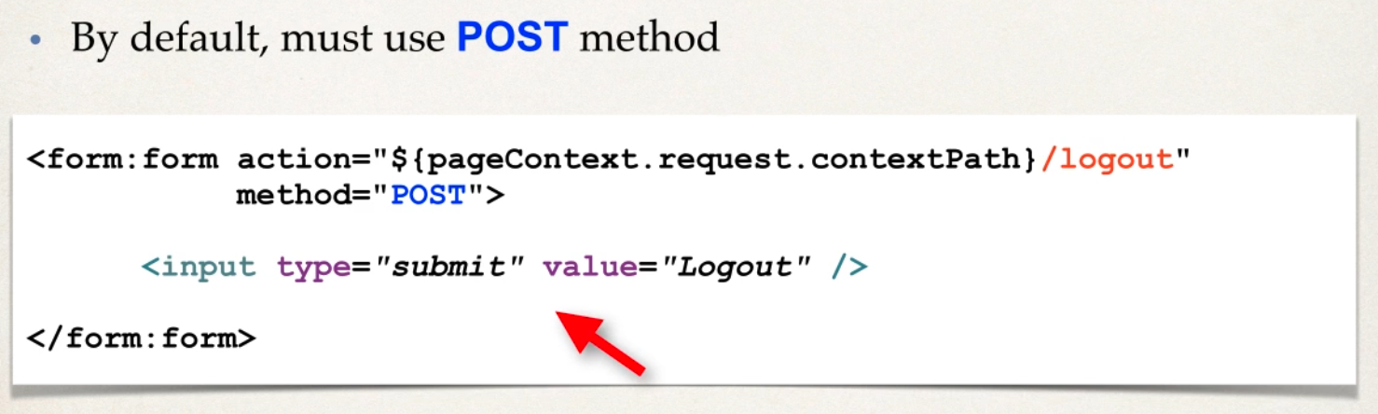

POST only bcz get method disabled by default

Logout Process

1 when logout is processed by default spring secuirty will do : invalidate users’s http session and remove session cookies etc

2 send user back to login page

3 append a logout parameter

Step 3

1 update login form

2 check logout parameter if it exist show log out message

<**c:if** test="${param.logout!=null}">

<i style="color: red;">You been Logged out</i>

</**c:if**>

Spring Security: Cross Site Request Forgery(CSRF)

Spring security protect against CSRF also called as “see surf”

A secuirty Attack where an evil website tricks you into execuitng an action on a web application that your cuurently logged in

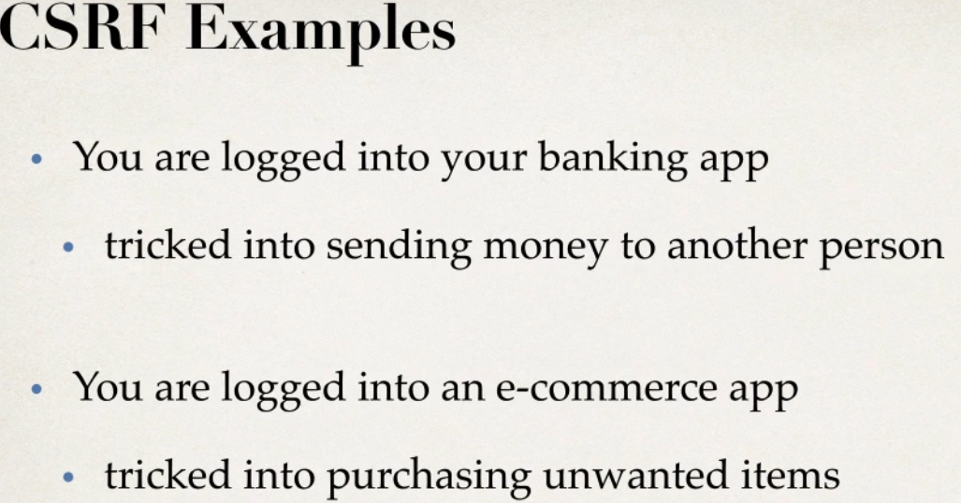

CSRF Protection

1 to protect against CSRF attacks

2 Embed additional authentication data/token into html forms

3 on subsequent request , web app will verify token before processing

- its a part of spring security Filter they actully generate a token and send back to the browser can be used in html

- spring secuirty filters will verify the tokens , validate if its valid for current user session before processing request

4 CSRF protection is enabled by default in spring security

5 Spring secuirty uses the synchronizer token pattern

6 each requst includes a session cookie and randomly generated token

7 for each processing spring security verifies token before processing

8 all handled by spring secuity filter in back end

When to use CSRF protection

1 for any norma browser l web request

2 if building a service for non browser clients (may have to disable CSRF protection )

TO Use Spring Security Protection

1 for Form submission use POST instead of GET

2 include CSRF token in the form submission

3 <form:form> automatically adds CSRF token if we dnt use this tag must mannuly add CSRF token but we have to this to every form request

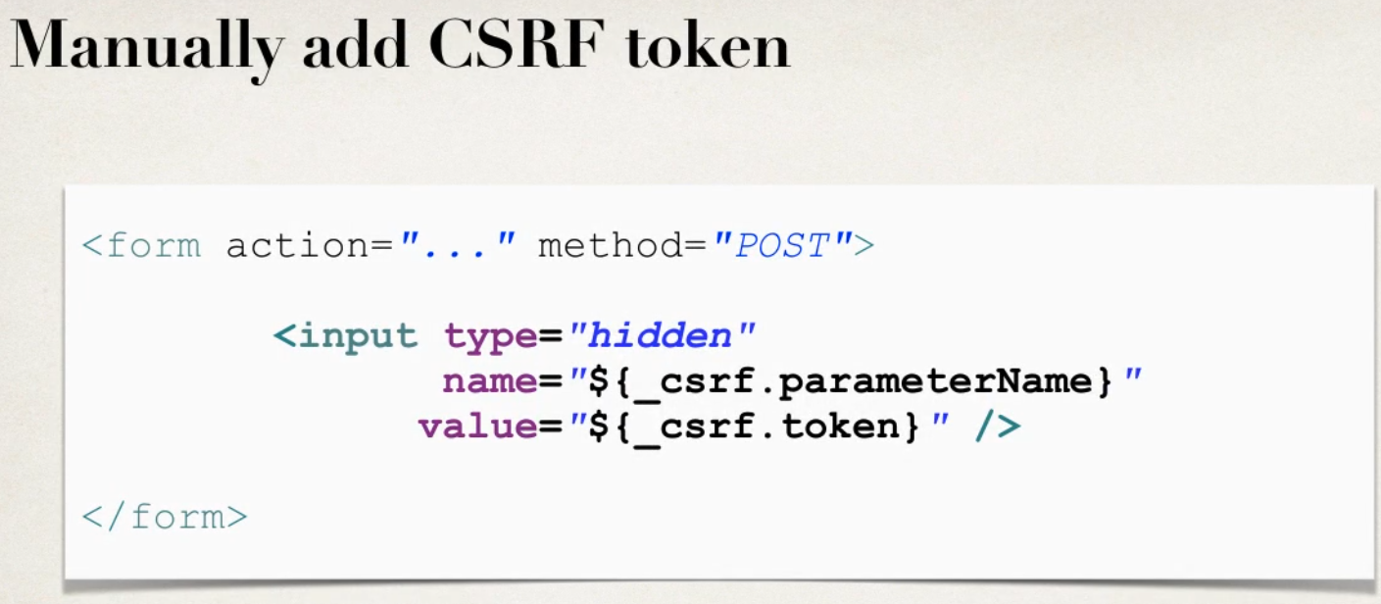

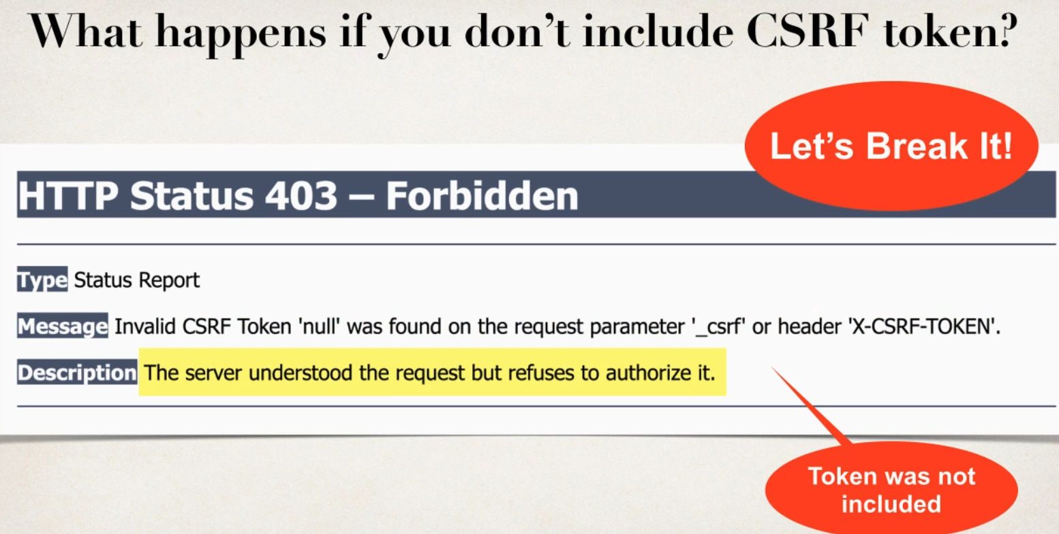

With out <form:form> normal form will get above response

Using <form:form>

In browser view page source

<input type="hidden" name="_csrf" value="ab0ee6fb-6522-42df-bdb7-4b5e81cb538f" />

Adding Mannualy CSRF in normal form

<!-- Mannualy adding tokens

jsp exp lang ${}

${_csrf.parameterName}

${_csrf.token} spring secuity will give value randommly generted fr given user session

-->

Displaying User ID and Roles

- Spring Security provides JSP custom tags for accessing user id and roles

Development process

1 Update POM file for Spring security JSP tags

<!-- Spring security JSP Tag Lib -->

<dependency>

<groupId>org.springframework.security</groupId>

<artifactId>spring-security-taglibs</artifactId>

<version>${springsecurity.version}</version>

</dependency>

2 Add spring secucity jsp tags library to jsp page then display USER ID and ROLE

<%@ **taglib** prefix="security" uri="http://www.springframework.org/security/tags" %>

USER :<**security:authentication** property="principal.username"/>

ROLE :<**security:authentication** property="principal.authorities"/>

Roles will be list or collections bcz mutiple roles can be der

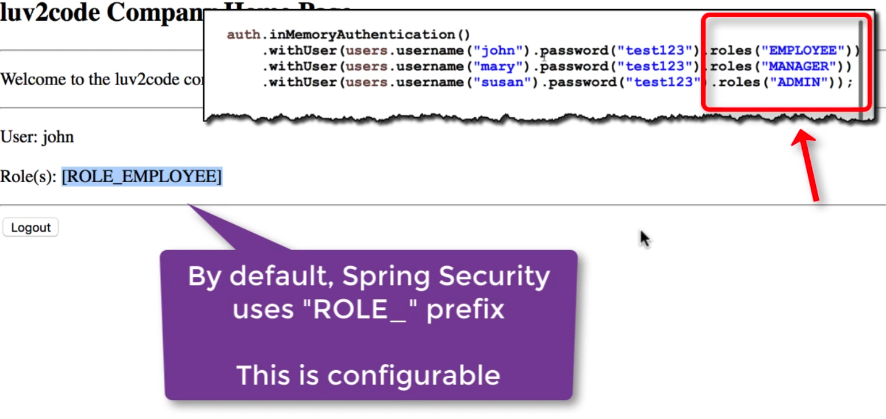

Can add multiple roles to user and can have any name for roles

@Override

protected void configure(AuthenticationManagerBuilder auth) throws Exception {

UserBuilder users= User.~~withDefaultPasswordEncoder~~();

auth.inMemoryAuthentication().withUser(users.username("sachin").password("password").roles("ADMIN"))

.withUser(users.username("darshan").password("password").roles("MANAGER"))

.withUser(users.username("manasa").password("password").roles("EMPOLYEE"))

.withUser(users.username("sachinhs").password("password").roles("EMPOLYEE","DEVELOPER","IT"));

}

Spring Security Restrict Access based roles

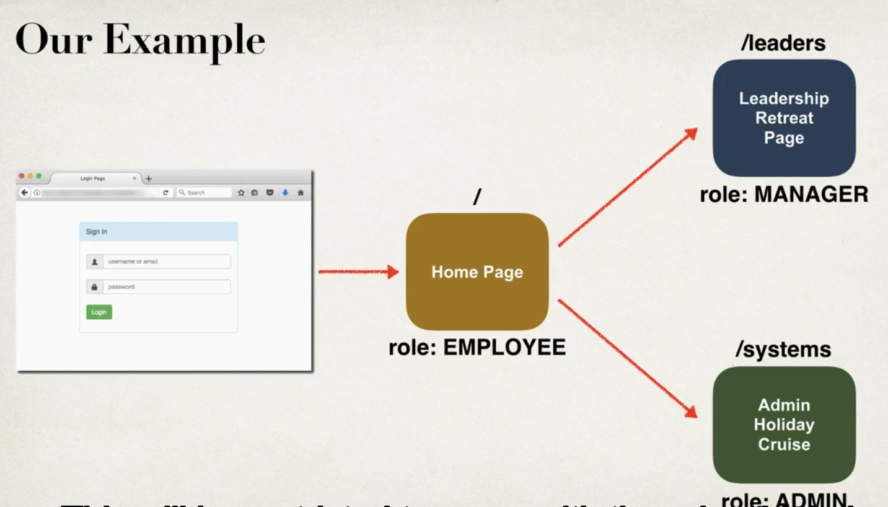

Development Process

1 create supporting controller code and view pages

2 Update user roles

3 Restrict Access based on roles

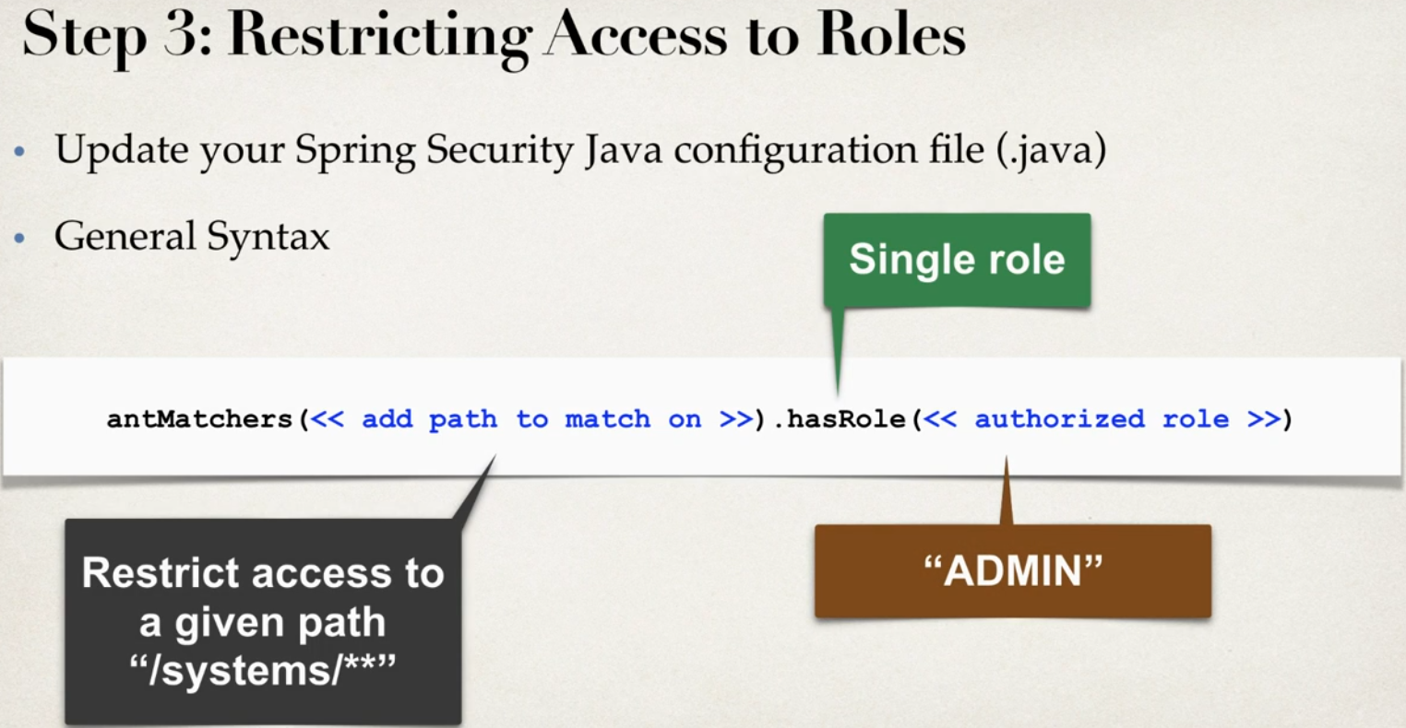

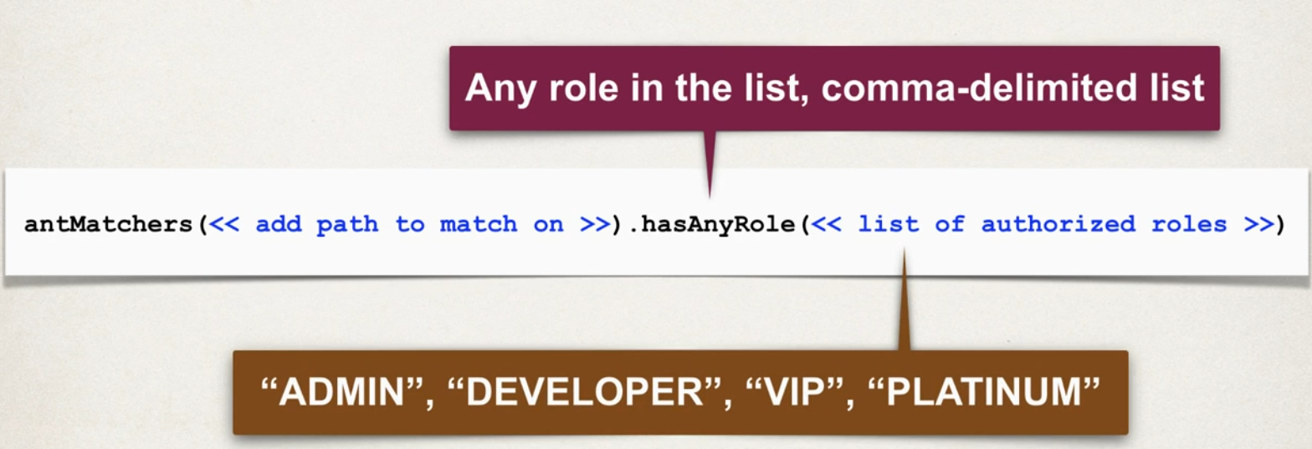

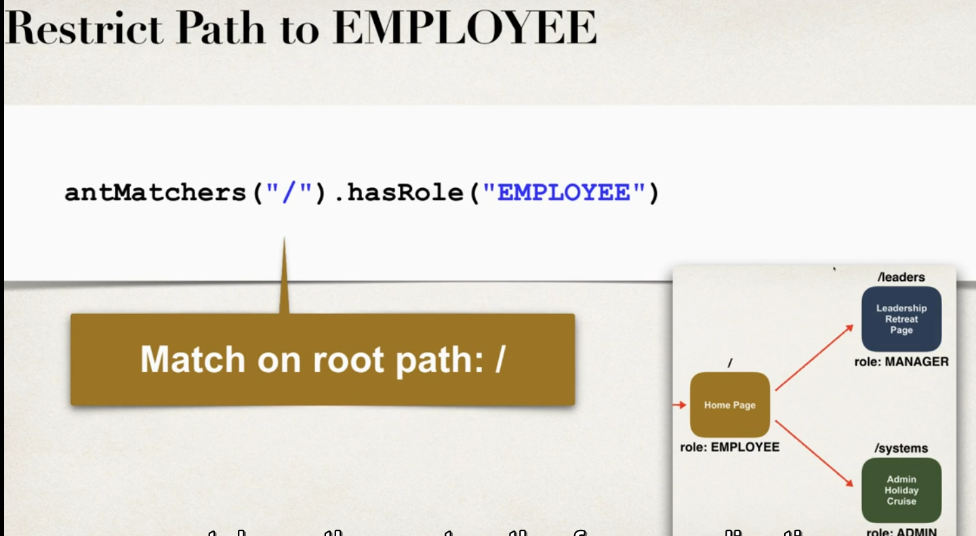

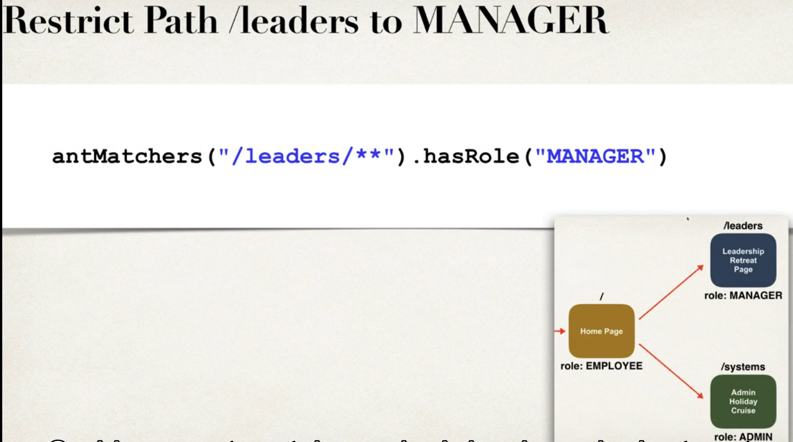

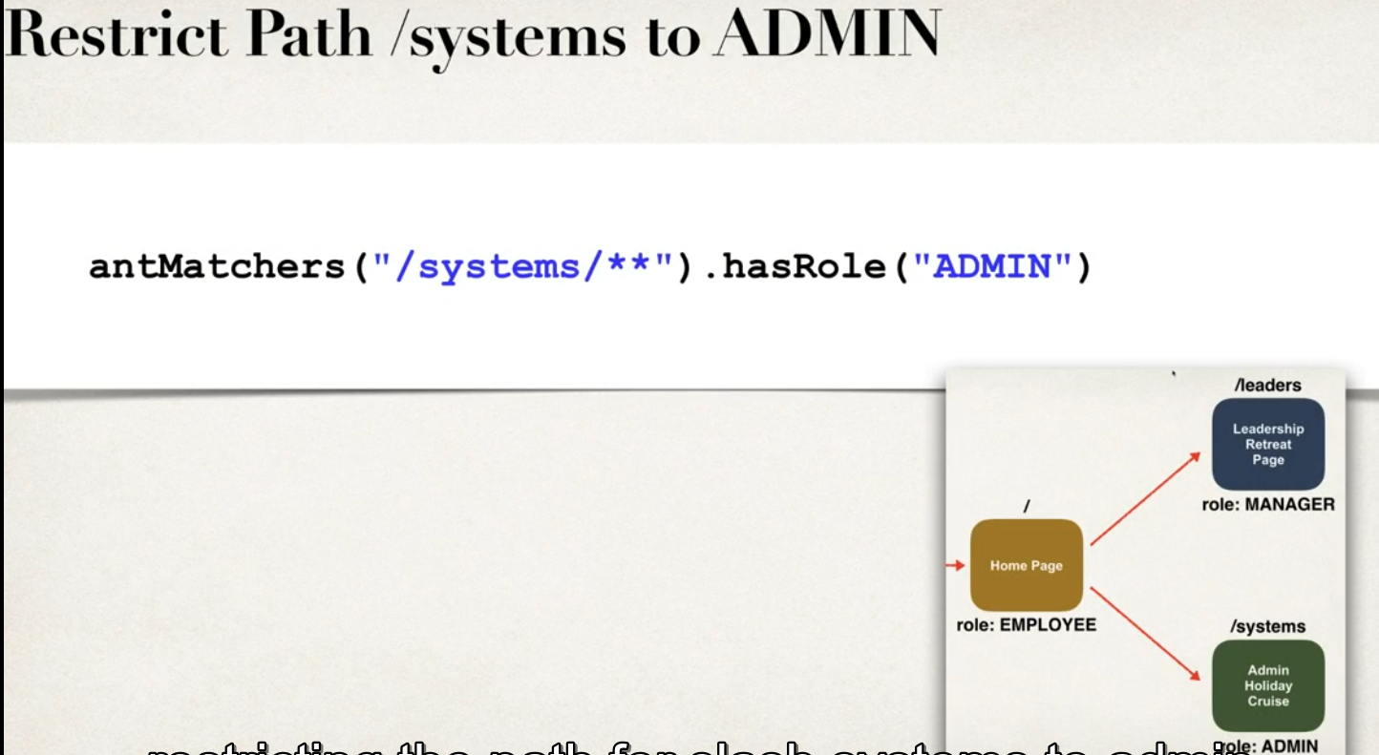

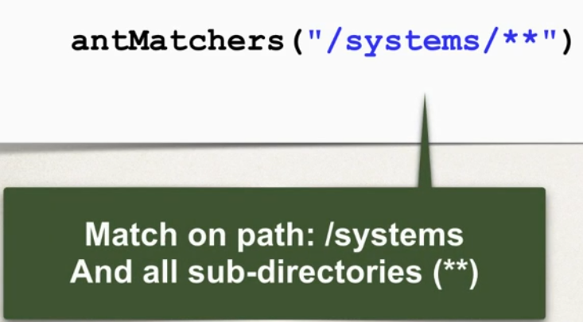

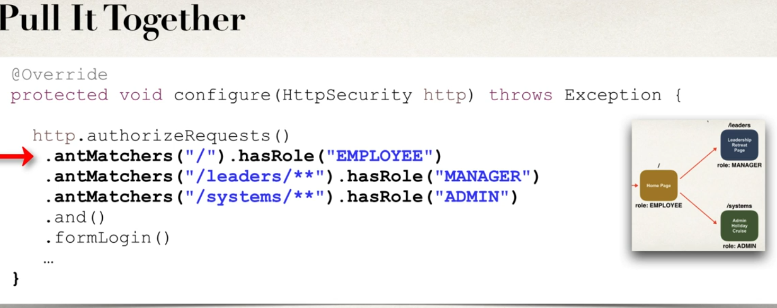

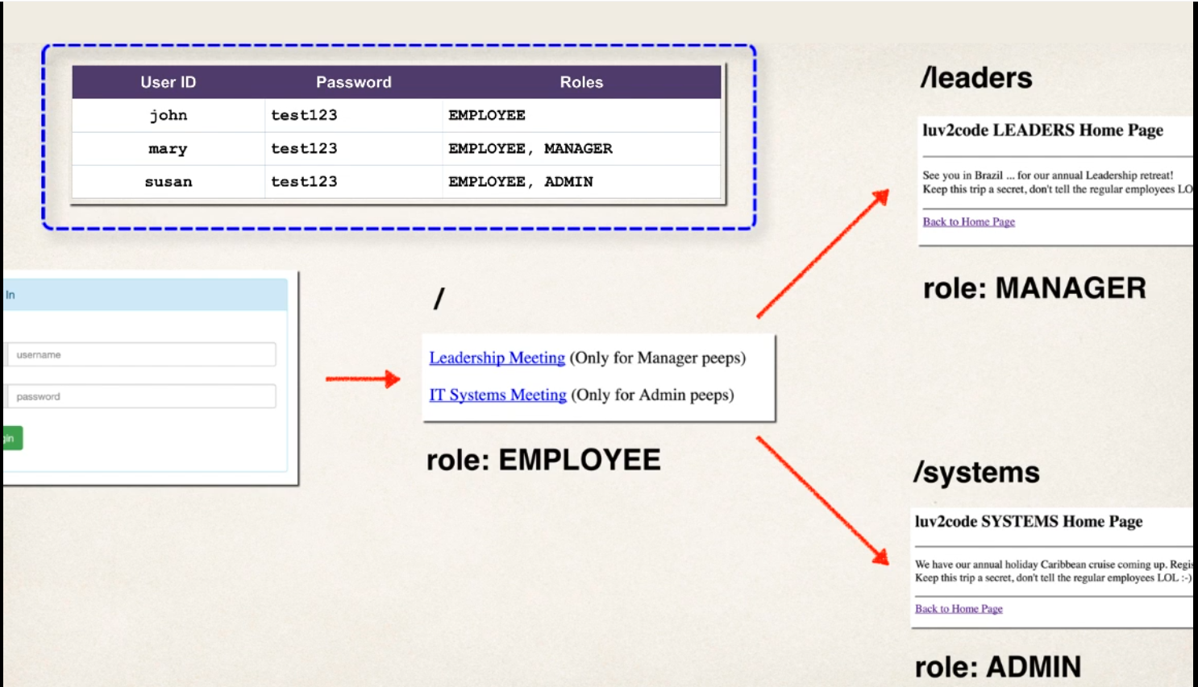

@Override

protected void configure(HttpSecurity http) throws Exception {

http.authorizeRequests()

//.anyRequest().authenticated() // * every request need to be authenticated * for restricting based on Role comment this line

// .anyRequest().authenticated() is commented to give role base access

.antMatchers("/").hasRole("EMPOLYEE") // root path to all employees roles

.antMatchers("/manager/**").hasRole("MANAGER") // this path to only managers ** will be sub directory path

.antMatchers("/system/**").hasRole("ADMIN") // this path to only admin ** will be sub directory path

.and()

.formLogin() // allow form Login

.loginPage("/loginpage") // Login Page

.loginProcessingUrl("/authenticateUser") // Form Login Athuntication URL

.permitAll()

.and()

.logout().permitAll() //add support to logout by default /logout url

;

}

Default Access Denied Page (403 handling page when role based error)

-create custom Access denied page

Development process

1 configure custom page for access denied

2 create controller supporting controller and view page

Step 1

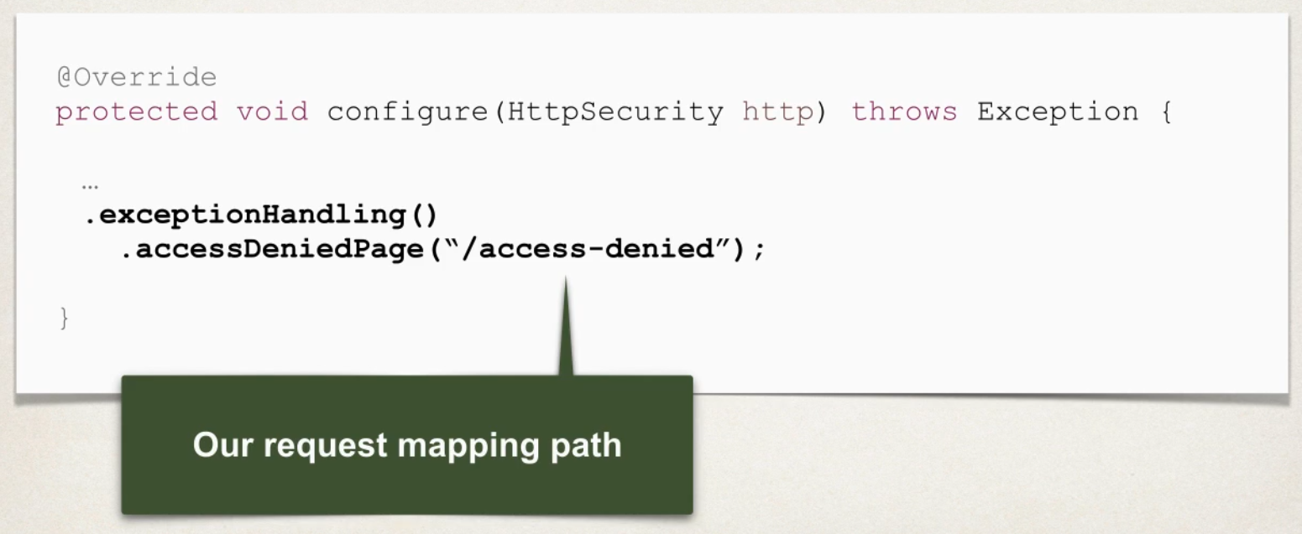

@Override

protected void configure(HttpSecurity http) throws Exception {

http.authorizeRequests()

//.anyRequest().authenticated() // * every request need to be authenticated * for restricting based on Role comment this line

// .anyRequest().authenticated() is commented to give role base access

.antMatchers("/").hasRole("EMPOLYEE") // root path to all employees roles

.antMatchers("/manager/**").hasRole("MANAGER") // this path to only managers ** will be sub directory path

.antMatchers("/system/**").hasRole("ADMIN") // this path to only admin ** will be sub directory path

.and()

.formLogin() // allow form Login

.loginPage("/loginpage") // Login Page

.loginProcessingUrl("/authenticateUser") // Form Login Athuntication URL

.permitAll()

.and()

.logout().permitAll() //add support to logout by default /logout url

.and().exceptionHandling().accessDeniedPage("/access-denied") // for handling Access denied Excpetion

;

}

Display Content Based on Role

-hide / show links(content) based on the roles

- use spring security JSP tags

- advantage using spring secuity tag is that not even using view source code they cant chck content inside spring secuity jstl tags